Current in Series and Parallel Circuits

Construct these circuits and measure the current for each ammeter.
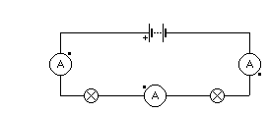
1
2
3

Ammeter | Current  (A)
1
2
3

In a series circuit the current

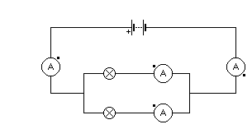
41
6
7
5
Ammeter | Current  (A)
4
5
6
7

In a parallel circuit the current

Current in Series and Parallel Circuits

Construct these circuits and measure the current for each ammeter.
1
2
3

Ammeter | Current  (A)
1
2
3

In a series circuit the current

41
6
7
5
Ammeter | Current  (A)
4
5
6
7

In a parallel circuit the current

